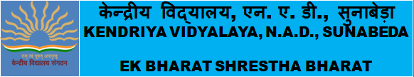

Different activities under EK BHARAT SHRESTHA BHARAT as per the EBSB Calendar and as specified by KVS through office correspondences are being conducted successfully in virtual mode.
Some photos of the EBSB activities are as under:-
- Theme Based Display Board
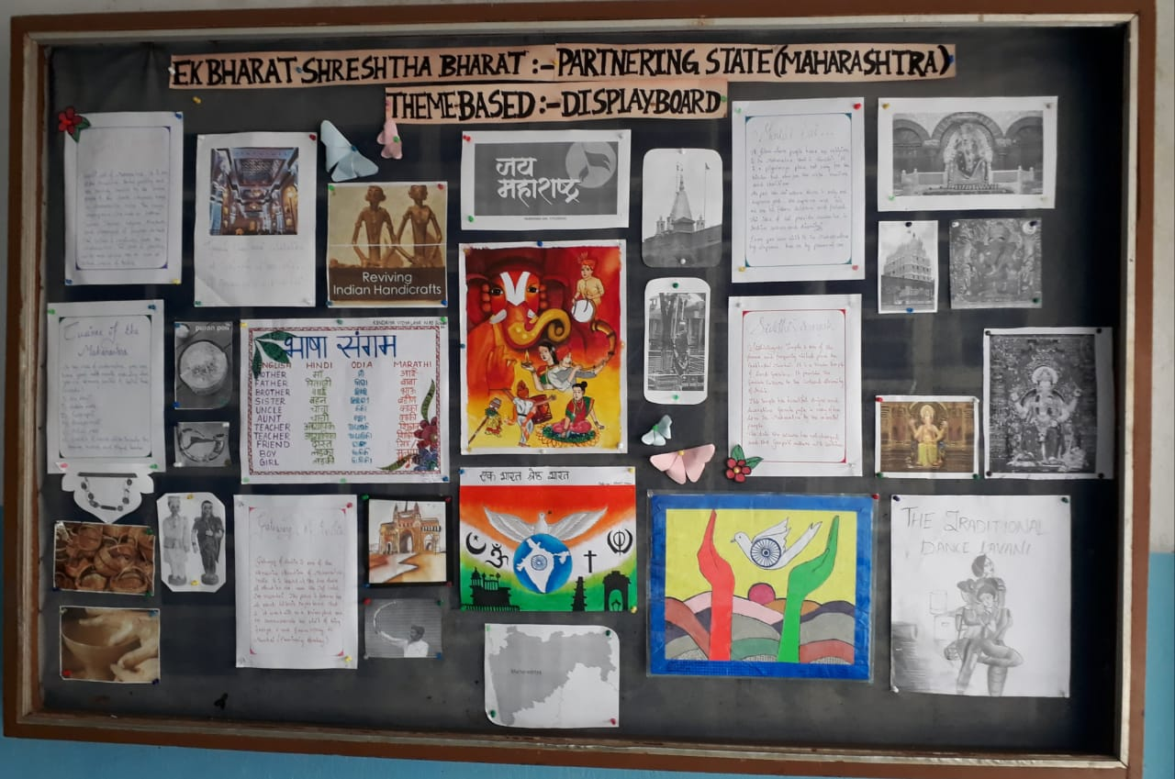

- Video conferencing with KV NMU Jalgaon

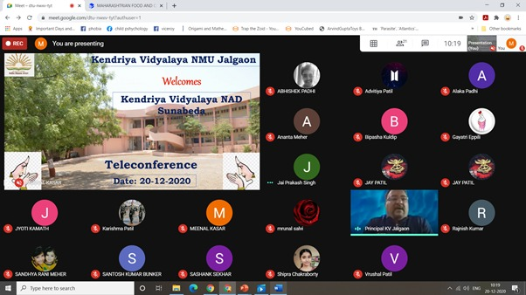

- Pledge
